Ben Menachem  
Nir Barzilay

**HW2**

**Question 1:**

Short description of the implementation: (nbs_tracking.m)

We implemented naïve tracking algorithm based on the NBS from HW1. On the binary output of the NBS we perform hole-filling & noise reduction, the result is that only big white blobs are drawn onto a black background. We compute bounding-boxes [bboxes] around the blobs in each frame. If in two consecutive frames, the same bboxes of the same blob are overlapping, we assume that this is the same blob, and draw the bbox around it.

In addition, we keep for each tracked blob a single-bbox-color through all the video.

How to use:

The algorithm itself is in the file "track_nbs.m". This is the matlab function that executes the algorithm.

The algorithm accepts 3 parameters: “VideoMat” – the original video loaded, "BlobSize" parameter which points what's the minimum size of an object to be tracked (This is one of the noise-control techniques), and “VideoMatBinary” which is the binary output of the change detection algorithm and our post-processing.

There's a script called "alg_exe_script1pets.m". This is our entry point for the execution of the algorithm.

Answers to the questions:

1. We controlled detection of significant blobs only, by setting the "BlobSize" parameter. We also used 2 MatLab functions: bwareopen(…) for additional noise reduction and imfill(…) for emphasizing filtered blobs.
2. With the BlobAnalysis tool we could compute bounding-boxes around blobs.
3. The blobs-overlapping technique is in the file " BBOverlapRatio.m":

SharedArea * 2 / (BoundingBox1Area + BoundingBox2Area)

1. We chose the second option. Before looping over the video frames, we calculate bbox for the first frame, in which the pedestrians are not detected = no pedestrians = no overlapping is found.
2. Quality report:

* The following 6 images are snapshots of 60 consecutive frames (movement from left to right):

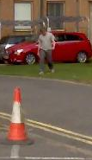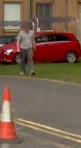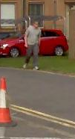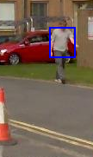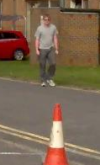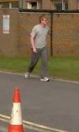

As can be observed, the pedestrian isn't big enough for the algorithm to track after him. One snapshot spotted the guy as big enough blob, but later it detected him as a small blob again. We could detect the pedestrian earlier if we would set the BlobSize parameter to a smaller value.

* However when the blob became big enough, the algorithm tracked him as a single blob (movement from left to right):

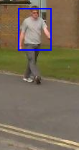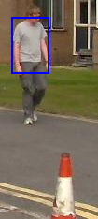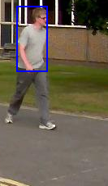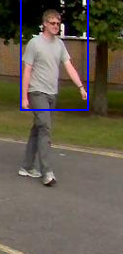

* In the following frames, another pedestrian comes in and is detected as 2 different blobs, **with the same BlobSize** **as before**, but then again as a single one (movement is from right to left):

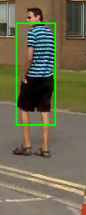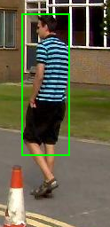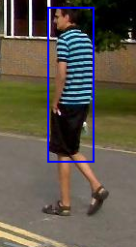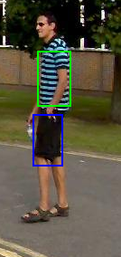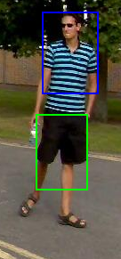

* And also the clouds are detected as blobs at some point:

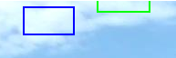

To sum the quality of the algorithm: In general, when the BlobSize is small, a pedestrian will be divided into more blobs, and more non-pedestrian-blobs will appear (false positives). When the BlobSize is big, small pedestrians won't be detected (more false negatives), because the algorithm ignores small blobs (which can be an actual pedestrian moving in the Z axis).

**Question 2:**

Short description of the implementation: (nbs_tracking2.m)

We used the basic tracking algorithm and modified it as such:

* + We keep a history of the bounding boxes from the last 2 frames
  + We use the center of each bounding box in the 2 frames to predict where the center of the bounding box in this frame will be.
  + We use the change in size of each bounding box in the last 2 frames to predict the size of the bounding box in this frame.
  + We match the currently discovered bounding boxes to the predicted bounding boxes by their overlay ratio.
  + If a bounding box is present in only one of the history frames we increase its “weakness”.
  + We unite discovered bounding boxes which were matched to the same predicted bounding box in case the overlap between themselves passes a certain threshold. When not united we select the one with the highest overlay ratio and match it to the predicted, and consider all other bounding boxes as new objects.
  + We create an average of all predicted bounding boxes and discovered bounding boxes. When a bounding box is present in only of those lists we add it but increase its “weakness”.
  + We remove all the bounding boxes that their weakness level passed a certain threshold. These were objects that were tracked but not shown on the image because the integrity of the result is in question, however there is still a chance that the object will still be discovered and regain the old bounding box that tracked it.
  + We add all the bounding boxes below a certain level of weakness, so that only strong prediction will appear on the image.

How to use:

The algorithm itself is in the file "track_nbs2.m".

There's a script called "alg_exe_script2pets.m". This is our entry point for the execution of the algorithm.

Answers to the questions:

1. The blob size is predicted to change because most moving objects in the scene move in a fashion that projecting them from the 3D scene to the 2D image resizes them in most frames. That way, while most rigid objects do not change their size in a 3D scene in real life (like humans or cars), their distance and location in space with respects to the camera influences the way the camera captures them, ergo, the way the light reflected from them is projected to the 2D plane the camera captures.
2. As described, our prediction is a simple linear prediction based on the last two frames.
3. We aimed to automatically mark each new blob and check whether it is associated to an existing blob or not. While this worked fine for objects with a clear line of sight to the camera that were easily detected by the change detection, it has caused problems with adjacent moving object and objects with hardly any movement or that blend well with the background.
4. The algorithm has a number of major drawbacks. The first being its dependency on the naïve change detection algorithm. The second being the simple prediction based solely on 2 frames. The first drawback causes unexpected blobs that are neither real changes in the scenes nor the whole object. This causes accidental bounding boxes to appear for a few frames until they are marked for deletion, seemingly tracking a non-real object, however this drawback also causes some changes to not be detected, causing a gap in the detection of an object in certain frames. In those cases our algorithm improves the result since our predicted bounding box will keep track of it.  
   The algorithm will be successful mostly on object that are moving in a linear line and constant speed on the projected capturing field of the camera. Also it will help continue the tracking over objects that were not detected for a few frames in the change detection.  
   The algorithm will fail when the movement is not linear or when the naïve change detection creates false positives.  
   In comparison to the algorithm in question 1, we could track an object more consecutively, but we also showed more false positives on our result.  
   Examples:   
   In frame 170 and 320 we are able to track the object while in Q1 we couldn’t  
     
     
    With prediction Without prediction  
      
     
     
     
     
     
     
     
     
     
     
     
     
    With prediction Without prediction  
     
     
     
     
     
     
     
     
     
   In frames 287 and 301 we keep following irrelevant objects we discovered in previous frames with no real evidence in the current frame:  
     
   With prediction Without prediction  
   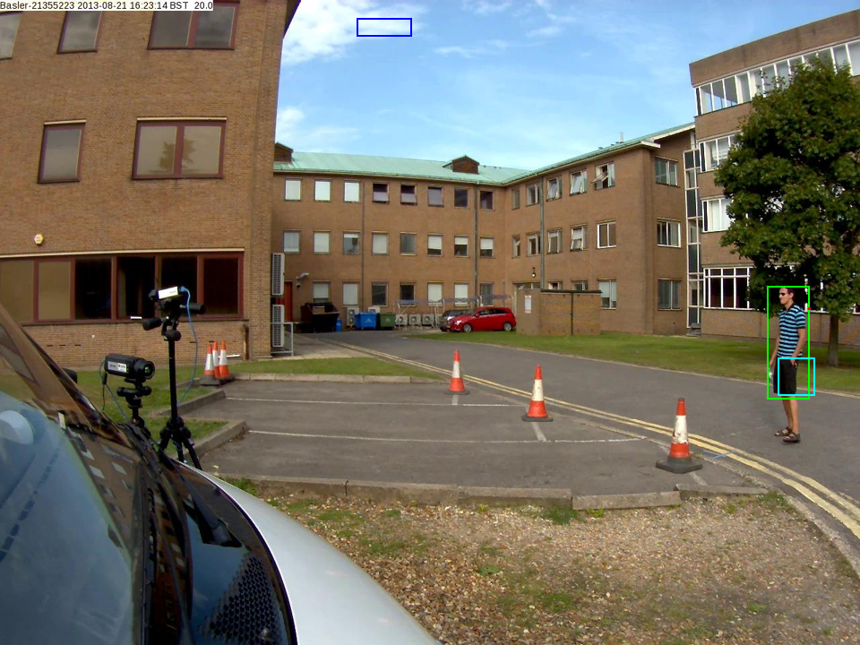 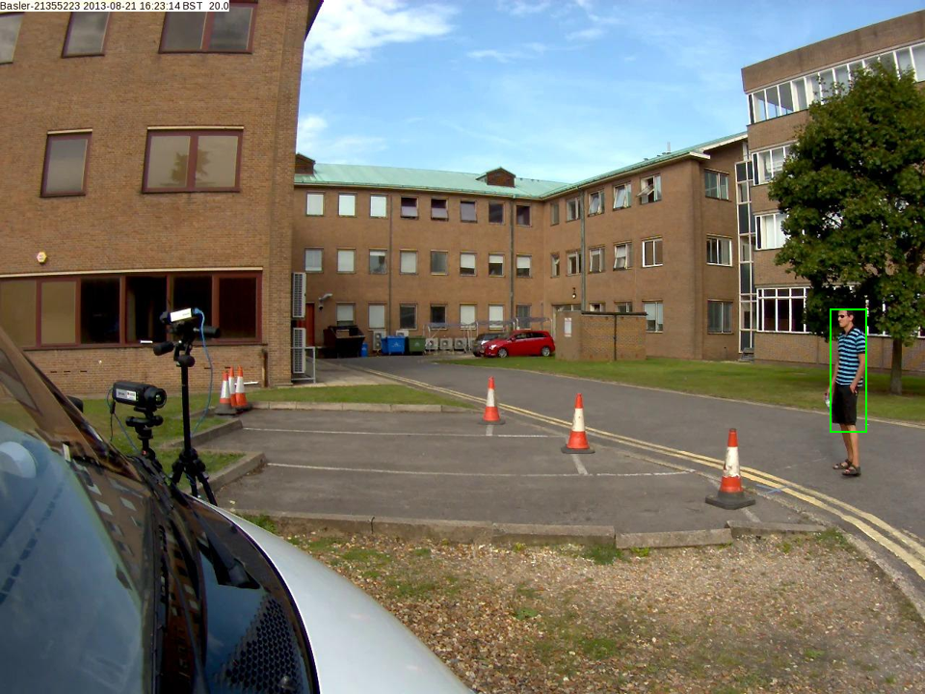  
     
     
     
   With prediction Without prediction

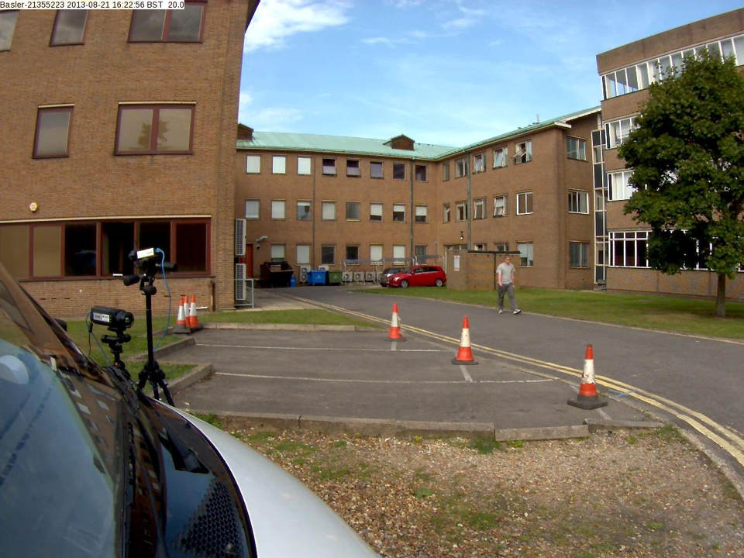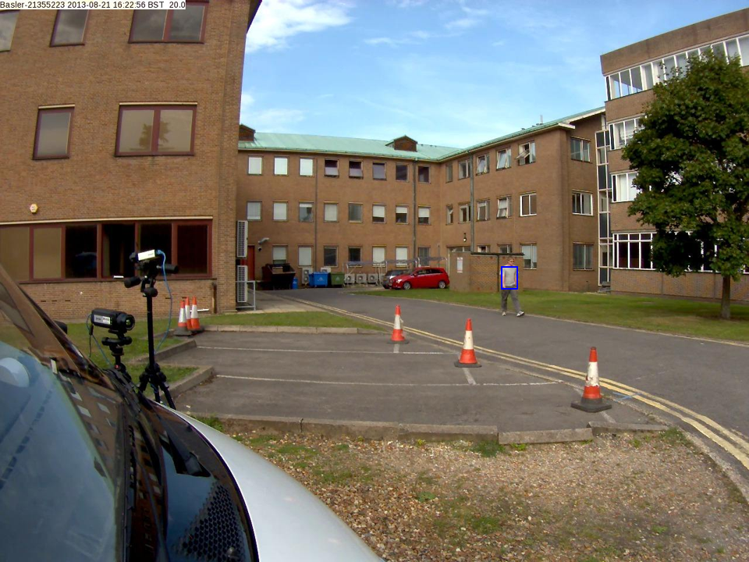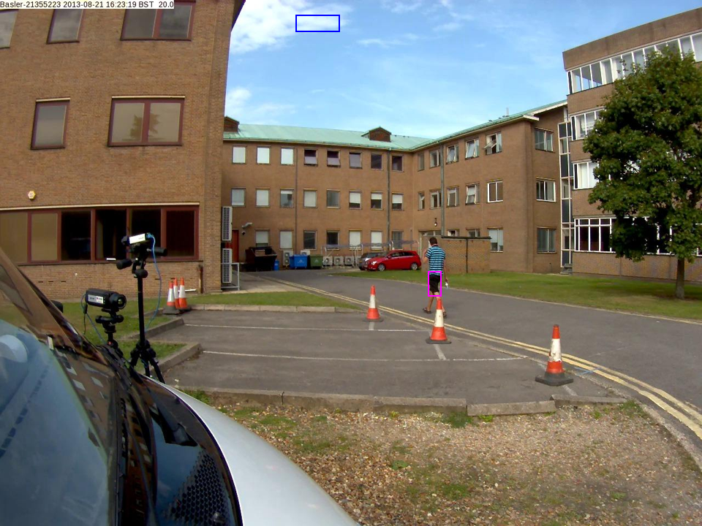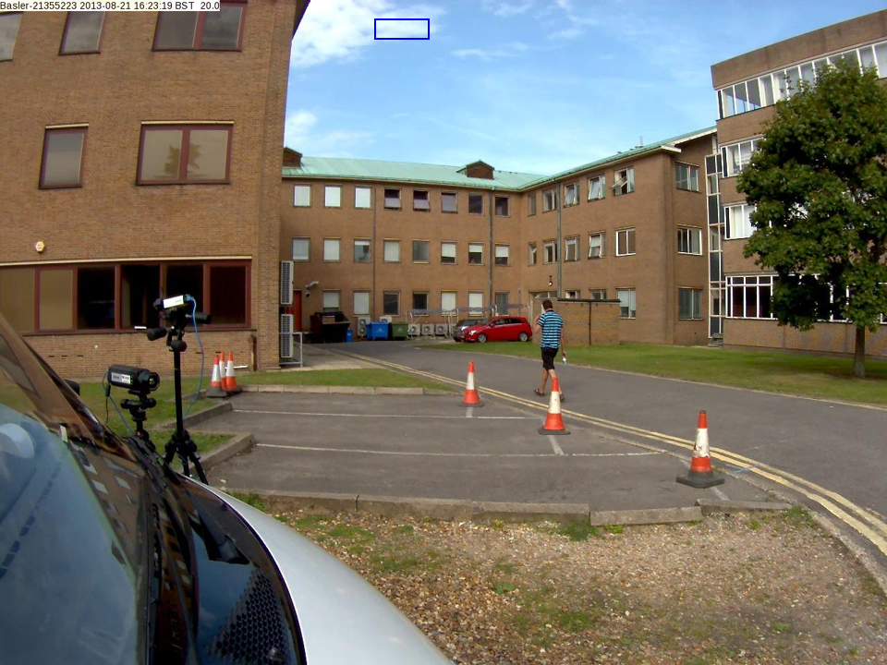

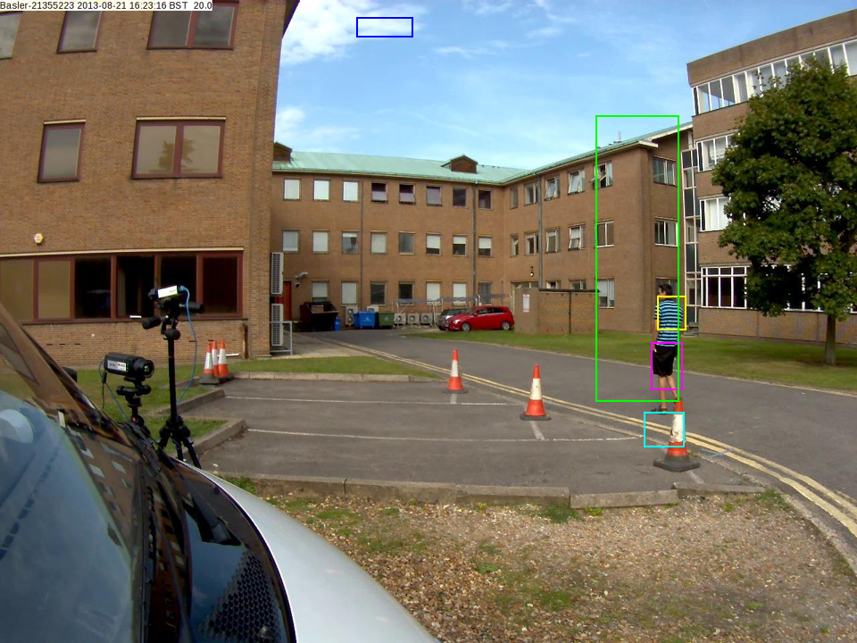

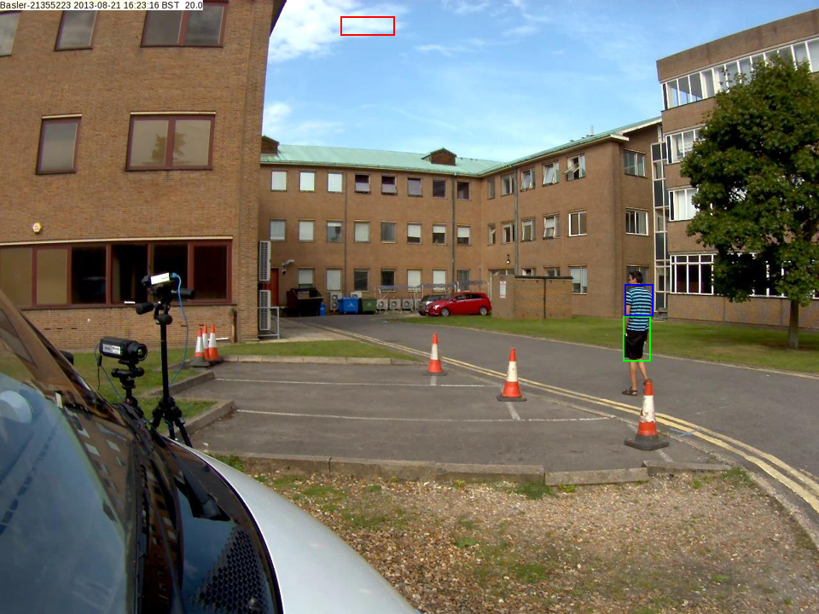

**Question 3:**

Once we have the predicted location of an object, we can use its predicted bounding area and mark for the change algorithm to be more sensitive in that are for changes, ergo, detect even more minute changes than the overall parameters allow. We can do this by having a second set of parameters we pass to the change detection algorithm that is more sensitive and could cause more false-positives in detection, but since it will affect only a small region in which movement is almost guaranteed by our prediction the result should be a clearer detection of the object we are tracking. This in result will give us a more accurate bounding area for the tracked object, which means in our calculations of where the bounding area should be more accurate since the error margin in detection is smaller, and thus giving us a more accurate tracking algorithm in total.

Our proposed algorithm for each frame

* For each bounding area predict the bounding area in the next frame
* Calculate the change detection on the next frame using two sets of parameters:  
  The first set will be a general set aimed to reduce false positives.  
  The second set will be a set aimed to detect smaller and more sensitive changes.  
  The first will run on all the image excluding areas that are predicted to have bounding areas in them.  
  The second set will run only on the areas that the bounding areas are supposed to be.
* Find the bounding areas on the changed detection image, and associate each bounding area with an existing one (or mark it as new).
* Calculate an average between the found bounding areas and predicted bounding areas and mark it on the original video.

**Question 4:**

Short description of the implementation: (nbs_tracking4.m)

We used the tracking algorithm from question 2 and modified it as such:

* + We keep a history of the bounding boxes from the last 2 frames
  + If we set “usePrediction” to 1, then we use the center of each bounding box in the 2 frames to predict where the center of the bounding box in this frame will be.
  + If we set “usePrediction” to 1, then we use the change in size of each bounding box in the last 2 frames to predict the size of the bounding box in this frame.
  + If “userPrediction” is 1:
    - We match the currently discovered bounding boxes to the predicted bounding boxes by their matching ratio which is a weighted average calculated from the bounding boxes histogram using SSD, cosine of the angle between them and the Bhattacharyya coefficient.
  + If “userPrediction” is 0
    - We match the currently discovered bounding boxes to the previous existing bounding boxes by their matching ratio which is a weighted average calculated from the bounding boxes histogram using SSD, cosine of the angle between them and the Bhattacharyya coefficient.
  + If a bounding box is present in only one of the history frames we increase its “weakness”.
  + We unite discovered bounding boxes which were matched to the same predicted bounding box in case the overlap between themselves passes a certain threshold. When not united we select the one with the highest overlay ratio and match it to the predicted, and consider all other bounding boxes as new objects.
  + If “userPrediction” is 1: We create an average of all predicted bounding boxes and discovered bounding boxes. When a bounding box is present in only of those lists we add it but increase its “weakness”.
  + We remove all the bounding boxes that their weakness level passed a certain threshold. These were objects that were tracked but not shown on the image because the integrity of the result is in question, however there is still a chance that the object will still be discovered and regain the old bounding box that tracked it.
  + We add all the bounding boxes below a certain level of weakness, so that only strong prediction will appear on the image.

How to use:

The algorithm itself is in the file "track_nbs4.m". It accepts one extra parameter from the track_nbs2.m – the “usePrediction” which is 1/0

There's a script called "alg_exe_script4AWalk.m". This is our entry point for the execution of the algorithm for part A. There's a script called "alg_exe_script4BWalk.m". This is our entry point for the execution of the algorithm for part B

Answers to the questions:

* 1. While the association of new bounding boxes to old ones is only by using a weighted average of different similarity functions on the normalized histograms, our results indicated that objects are easily identified and distinguished from one another only by this feature. In cases of multiple associations of new bounding boxes to the same existing one we do give preference to the one overlaps the most, but in most cases this check is dimmed unnecessary. However, using this method is still sensitive to the underlying change detection algorithm, resulting in problems with occluded objects or false negatives. For example while using the question 2 algorithm as comparison, our algorithm could not detect (or predict) 2 bounding box in an area with two close people, while the prediction in this case was more accurate (Frame 168 in walk):  
     Histogram matching Prediction  
     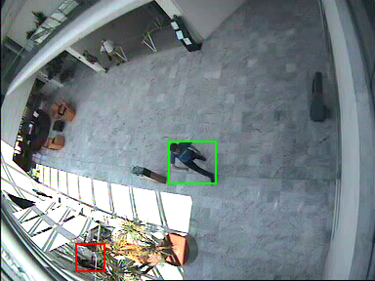 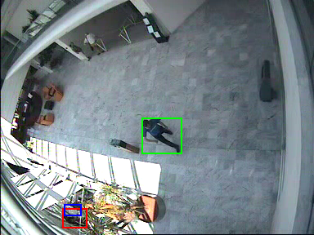
  2. Using histogram matching on our prediction algorithm decreases the amount of false positive bounding boxes in comparison to only using the prediction algorithm. This is probably since the usage of color matching enables us to associate the bounding boxes more accurately causing us to predict more accurately which in turn causes less erroneous boxes to be shown.  
       
     Example ( Frames 355,356,363):  
     With histogram prediction:  
     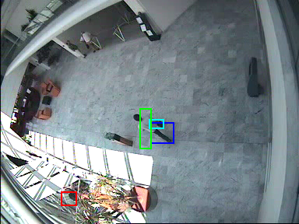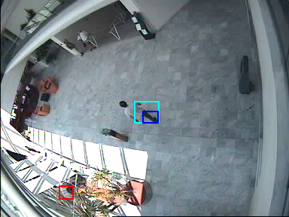  
       
     With only prediction:  
     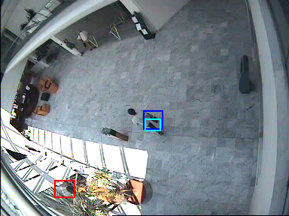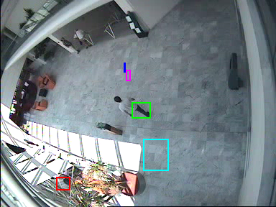

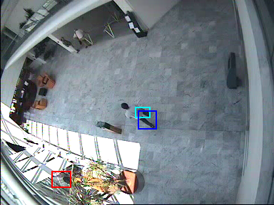

* 1. Prediction is only possible when we assume something on the motion, such as linearity on the next frame based on previous frames or some sort of continuous motion. When those assumptions fail we will not be able to predict the movement of an object. For example a man who runs, stops, and runs again. While it is possible to predict his location in each part, the transition between the different types of movement will cause us to wrongly predict his location. We will predict that he will keep running when in fact he stopped moving and we will predict he is still stationary while he started running again.

**Question 5**:

Notes:

* The algorithm was executed on frames 1-40 of PETS2014-0101 video, and scaled down by 50% for making our computer able to process it.
* The algorithm is implemented in **q5_main.m**, **integralHistogramTracking.m**, **getIntegralHistogram.m**, **findBestIhModel.m**
* Functions' parameters are documented in the function definition.

1. Short description of the algorithm:

The algorithm perform tracing on objects by looking for their histograms in every frame. The objects-to-track (= **models**) initial tracking details are inserted manually (e.g. their location), and also their **histogram** for the first frame is calculated. In every consecutive frame, we look for the model in some **region** around it by doing exhaustive search for **candidate-model-histogram** in that region. Using the region's integral histogram, the exhaustive search is quickly performed. In every exhaustive-search-round, the algorithm tests candidates-models with 75%, 100% and 125% size of the original model in order to support scaling (this is available due to normalization of the histograms). When the best candidate is chosen, a box is drawn around it in the video frames. If after certain consecutive frames the object is not found on the screen, it's no longer tracked (if the gap between the original histogram and the new is larger than a threshold, for X consecutive frames, the algorithm no longer tracks that object).

1. Tracking results:

We tested our video on the PETS2014-0101 video from the given DATA folder. The algorithm managed to track objects (motion is from left to right):

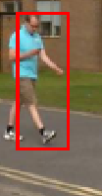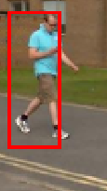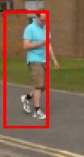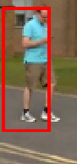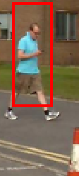

However when arriving to the conus in the last frame above, the algorithm found that the conus should be part of the pedestrians we track, but was able to recover few frames later:

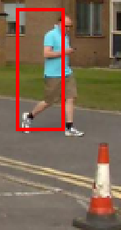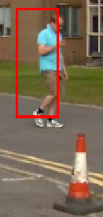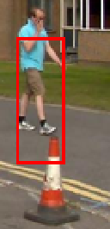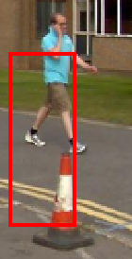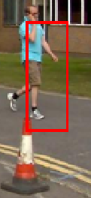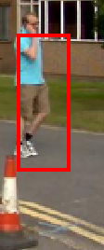

This is due to the color of the wall behind the pedestrian, which has similar colors to the conus, and when there's less wall, there'll be more conus.

There's another aspect that affects the algorithm performance: resolution.

There are 2 more pedestrians that the algorithm was told to track on (gray & yellow pedestrians):

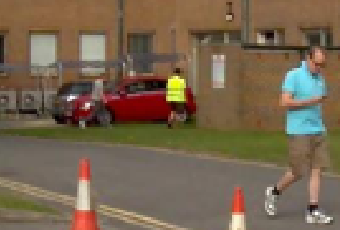

Let's look at them a little closer:

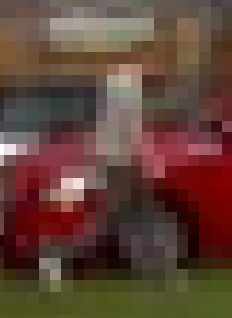 

The histogram of the left pedestrian is very similar to other histograms around it, such as where the algorithm "detects" him in the next frame:



And is very hard to detect. The other pedestrian is very different from his environment and therefore the algorithm manages to track him:

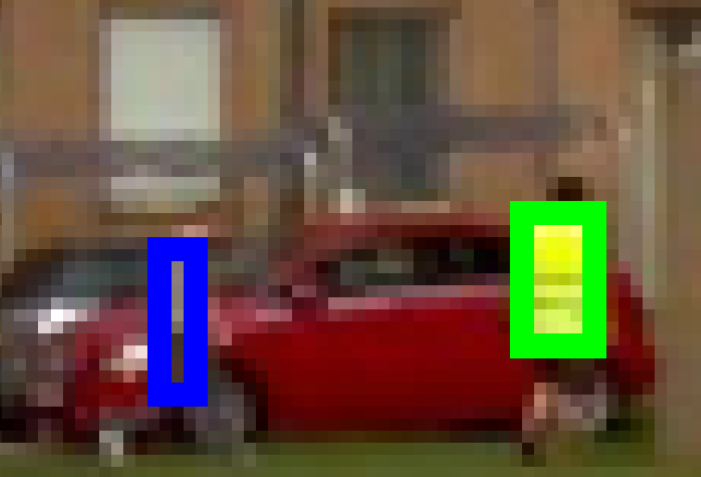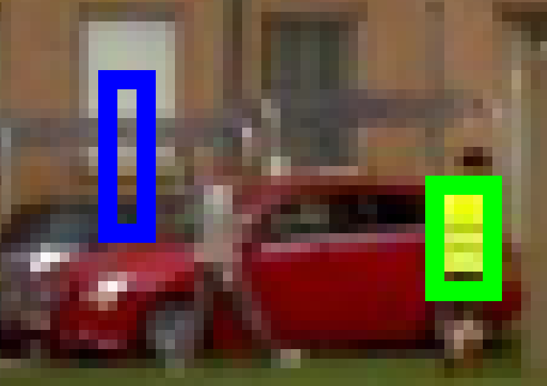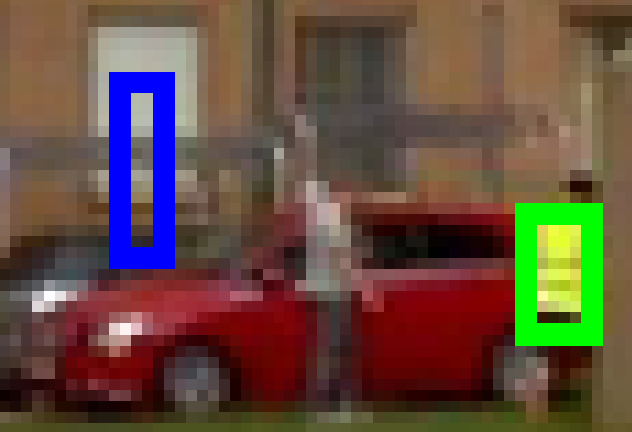

The algorithm didn't notice the gray guy at all, since he looks like his environment.

To summarize up the results: the algorithm can effectively track objects and is sensitive to the model's histogram changes. However the resolution is a major player especially here, since as the resolution is lower it is hard to detect the tracked objects.

1. There are a few differences in the 3 algorithms.   
   Detecting an object: While algorithm (2) and (4) rely on change detection and thus enabling them to discover newly entered objects to the scene, algorithm (5) uses integral histogram, which means that we need a different way to discover objects or enter them by hand.  
   Discarding an object: While algorithm (2) and (4) use change detection, algorithm (5) uses only specified objects and histograms. This cause (5) to be less susceptible to false positives that occur in the change detection, but also creates an issue when an object genuinely disappears (like entering a door). While (2) and (4) do understand that the object tracked disappeared, discovering such a thing using only the integral histogram is difficult.  
   Size of object: Since (2) and (4) are based on blobs, the size of the bounding box adjusts in each frame so that there is a connection between the object’s size and its bounding box. However, in (5) we define the initial size and do not change it during the tracking. This can cause the bounding box size to be misleading and for the histogram to misrepresent the model. For example a bounding box surrounding a human that walks away from the camera will eventually contain more background and could potentially track it instead of the human. On the other hand, since we define the size ourselves, the effect of splitting bounding boxes as we witness in (2) and (4) do not occur in (5) and we get a steadier tracking bounding box and fewer false positives.

**Question 6:**

Notes:

* The algorithm was executed on frames 360-460 of Walk2.mpeg.
* Functions' parameters are documented in the function definition.

1. For tracking objects we will use the algorithm in question 5, using integral histograms. The method for determining when people are getting close to each other is by looking at their **search region** around them. A search region is the area around the tracked object, that we will exhaustively-search it in the next frame. When 2 search regions are overlapping each other 🡪 the objects may be close to each other in the next frames 🡪 we draw a red line between them.

The method will absolutely fail for objects that are close on X & Y axes but far on the Z axis (when one object is more "deeper" than the other), because the algorithm do not support the Z axis. The method will also fail when at the 1st frame the two objects are near each other, but in the next frames are getting far from each other. So until their regions won't overlap anymore, even though they are getting far from each other – the algorithm will mark them as "getting close".

1. Implemented in **integralHistogramTracking.m**. Depend on parameter 'check_proximity'. parameter
2. Implemented in q6_c.m.

The following is a snapshot of the result. When 2 objects are close to each other, a red line is stretched between them (motion is from left to right):

